Assignment for **Oracle E- Business Procurement/Purchasing**

Date:22nd Nov-2024

[Provide screenshots of each step (which performed in a live environment).  
As evidence all the activity screens shot needs to be attached].

3. Check one of the existing Supplier, check this Supplier eligible for the Followings or not.

**RFQ , Purchasing, Payment**

**First we log into the oracle application, where we log in as Operations (Password is: welcome)**

**Then we follow the path: Purchasing, Vision>Supply Base> Suppliers**

**Then scroll down and click “update”**

**For this I’m using “3M Health Care”**

**Then we click on “Address Book”**

**Then we click on “Update”**

**We see that this supplier is eligible for “Purchasing” and “Payment”, and not for “RFQ Only”**

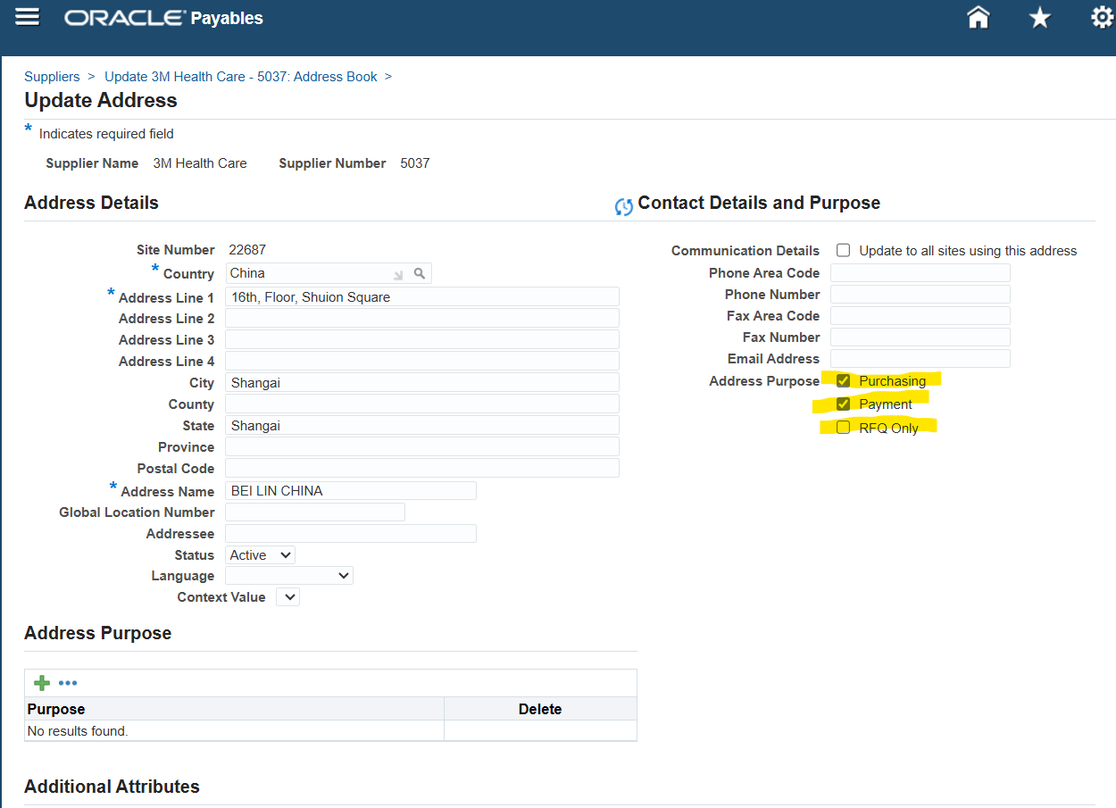

4. For The same above Supplier checks the Bank details & Payment Method.

Starting where the previous question left off, we’re going to click on “Banking Details” on the left

As we can see, there are no results found. Next we click on “Payment Details”, also on the lefthand side

Doing so, we see that the payment method for this supplier is “Check”, which is the default payment method.

5. Query one existing Requisition & check what are all information has been captured/update for the respective Requisition.

First the path: Purchasing, Vision Operations>Requisitions>Requisitions

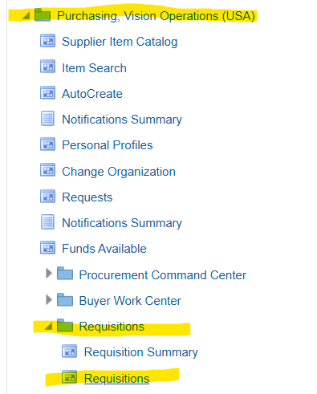

This menu is brought up:

Then we click on “Number” and then “View” and then “Find”

Then we enter the number or name of our requisition – in this example I’ll just be picking the first result for ease of access – so I’ll be querying with the %

Then clicked on find, then clicked on the first result, which is 186 here, then clicked on “Ok”

Then all of the tabs can be clicked through to view the information about this requisition:

Additionally there is the “Distributions” option which shows some more information.

6. Query one existing PO & check what are all information has been captured/update for the respective PO.

First we get the path: Purchasing, Vision Operations (USA)>Purchase Orders>Purchase Orders

Which Brings up this screen:

Again we’ll click on “View” and then “Find”

Which brings up this screen where we again use the “%” symbol, and for our example purposes click on the first result:

Then we click through the various tabs for this Purchase Order:

7.Explain the key modules of Oracle EBS Procurement Suite.

Suppliers are a key module because you must have suppliers set up to buy things from them.

In the setup section, there’s four options under “Organizations”. Of those, Purchasing, Financial, and Receiving must be set up to run procurement business processes.

There are also items, which are apart of the master data for the procurement process. You must have items to procure items.

10. What is the **PROCUREMENT/PURCHASING** key Configuration?  
Each of the setup component what are all Information in captured while configuring need to demonstrate.

As in question 7 the following screenshot shows the three most important configurations: Financial, Purchasing, & Receiving Options.

As displayed below here is the purchasing information (given in this case for the operation unit Vision Operations):

For receiving options we first click on inventory organization, for our example we’ll use Vision Operations

And here are our important receiving options:

For our third we have financial options, accessed from the same area as the other three.

And showing the various tabs:

11. Navigate Provide screenshots or descriptions of the following:

* The requisition.
* Purchase Order.
* Receipt for PO.

Requisitions are where there is an internal demand raised for materials or something similar.

Navigation is: Purchasing>Requisitions>Requisitions

Purchase Order is an official document sent to suppliers asking for supplies.

Navigation: Purchasing>Purchase Orders>Purchase Orders

The receipt for a Purchase Order is something we have whenever we have received goods from a supplier. We don’t get one selling goods.

Navigation: Purchasing>Receiving>Receipts

We’ll use Vision Operations for our example

Click “Find”

I clicked away the next pop-up:

Which leads us to receipts:

12. Your company requires the following items for a project:

* 5 Desktop Computers
* 10 Office Chairs

You are tasked to procure these items using Oracle Procurement.

Steps to Complete:

13. **Create a Supplier:**

* If the supplier doesn't exist, create a new supplier record, including address, contact information, and payment terms.

Creating a supplier navigation: Purchasing>Supply Base>Suppliers

Then click “Create Supplier”

Next we create the supplier name – In this case xx_jacob_supplier. I also assigned tax country as US.

Then we go to the address book, then click “Create”

For fun I’m going to try using the address of the New York Stock Exchange

Added in the address, plus enabled purchasing and payment, which will be needed to ever fulfil a purchase order with this supplier. Entered address name as “xx_jacob_supplier_address”

Made a contact named xx_jacob_contact

Added check as the payment method

14. **Create a Requisition:**

**First the path: Purchasing>Requisitions>Requisitions**

Then putting in all of the information -> I found the closest thing to a desktop computer. 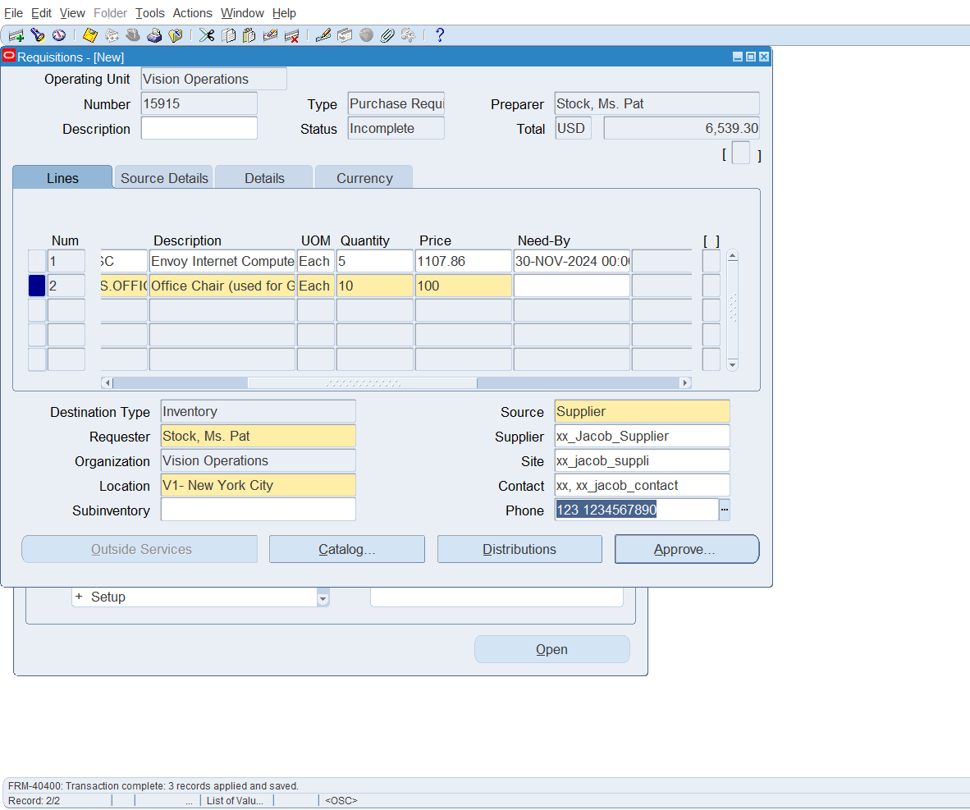

Along with current quantities.

15.**Create a New Purchase Order**: Standard with currency type as USD

Enter **Order Information**:

* **Supplier**: Select the supplier from the list of available suppliers.
* **Order Type**: Choose the appropriate order type (for example, **Standard**).

First the navigation: purchasing>purchase orders>purchase orders

Then we put in the information:

The supplier info and items are the same as in the requisition.

16. Create a Quotation for any of the existing supplier.

First the navigation: purchasing>rfq’s and quotations>quotations

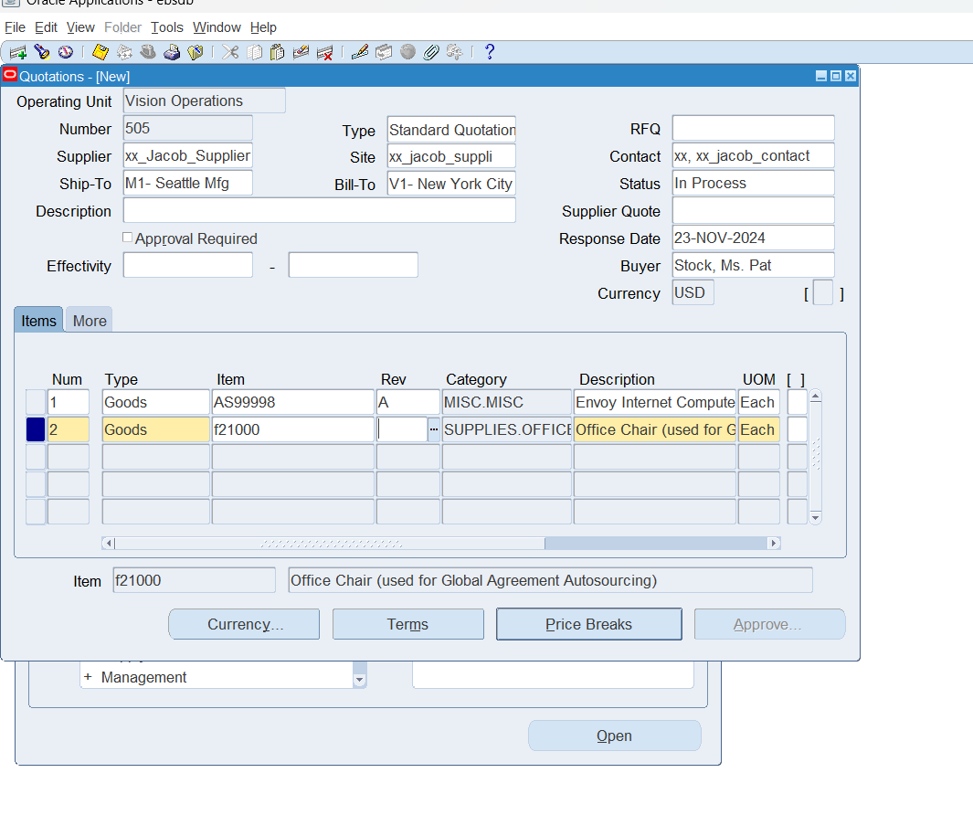

17. Verify all accounts which are updated for financial options.

Not entirely sure what this question is asking for, so I took it to mean the accounts in vision operations.

First the path: Purchasing>Setup>Organizations>Financial Options

Then the accounts which are verified for different things in the gl accounts:

